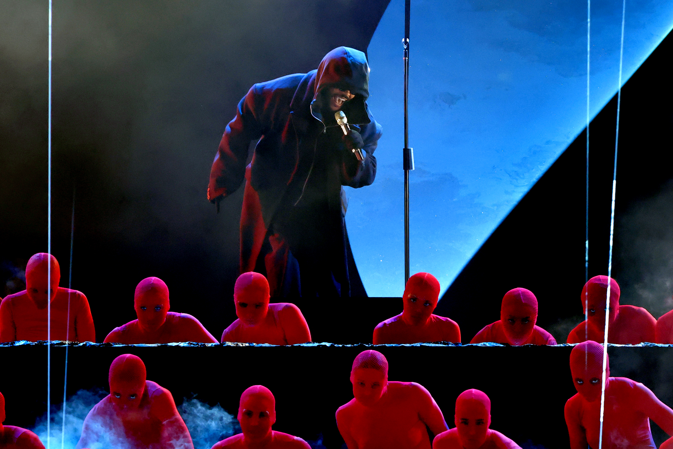
Photo Credit: Courtesy of the Recording Academy® / Photo by Kevin Winter for Getty Images © 2025

The Weeknd and Lady Gaga Choose Sennheiser and Neumann for Moving Performances at 67th GRAMMY Awards® as the Music Industry Comes Together to Support Los Angeles

Sennheiser was the choice for several winners and nominees at the GRAMMY Awards®, while the Sennheiser Group pledged commitment to the music industry beyond the stage by supporting the Recording Academy® to bolster MusiCares®’ Los Angeles fire relief efforts.

Los Angeles, CA – February 20, 2025 – The 67th Annual GRAMMY Awards® took place on February 2, airing live from Crypto.com Arena in Los Angeles and once again hosted by comedian Trevor Noah. The night was filled with the biggest stars in music, featuring performances by The Weeknd, Shakira, Lady Gaga, Janelle Monáe, Cynthia Erivo, and Shaboozey – whose teams all chose Sennheiser and Neumann to amplify their voices, including Sennheiser’s Digital 6000 wireless system. The ceremony looked very different this year as it was reworked to shift the focus towards the devastating situation in Los Angeles and raise funds to support those impacted by the unprecedented fires across the city that so many artists and creatives call home. Throughout the GRAMMY weekend broadcasts, the Recording Academy® raised over $24 million for fire relief efforts via MusiCares®, supported by corporate sponsors like the Sennheiser Group. The Recording Academy’s efforts showcased how the broader music industry was able to come together quickly to make a real difference for its LA communities.

Remarkable Performances to Celebrate Music’s Biggest Night
A highlight of the night was The Weeknd, who made a surprise performance that was introduced by Recording Academy CEO Harvey Mason jr. and featured two new songs, “Cry For Me” and “Timeless” from his recently released album, Hurry Up Tomorrow. The R&B pop singer was also nominated for Best Melodic Rap Performance. An MD 5235 capsule was paired with an SKM 5200-II microphone and EM 3732 receiver for the alluring spectacle.

Among the noteworthy performances was Latin music royalty Shakira, who won her fourth GRAMMY Award for her album Las Mujeres Ya No Lloran. Her performances of “Ojos Así” and “Shakira: Bzrp Music Sessions, Vol. 53” were powered by Sennheiser’s Digital 6000 Series and an MM 435 capsule. “[The capsule] was great because Shakira was in front of the whole PA,” says broadcast music mixer John Harris, who has been mixing GRAMMY telecasts since 1989. “She was out in the house, it’s all just wide open, and then ends up on Stage B. [It was a] challenging circumstance and those capsules came through like champs.”

A Tribute to the Timeless Quincy Jones Sounded Like Magic
It was for this same reason that reliable, premium gear for Janelle Monáe’s performance was non-negotiable. The singer, who paid homage to the late Quincy Jones with a performance of the Michael Jackson hit, “Don’t Stop ‘Til You Get Enough,” started out on-stage before running out into the house, dancing on a table, throwing her mic to someone, and then running about 120 feet back to the stage. It was a technically demanding sequence that went uninterrupted while using the Digital 6000 wireless system.

During the same tribute performance, Wicked star Cynthia Erivo was accompanied by Herbie Hancock for a rendition of “Fly Me To The Moon,” a song that was arranged by Jones in 1964 for Frank Sinatra and Count Basie. Using a Neumann KK 205 capsule, SKM 6000 handheld transmitter, and EM 6000 receiver, Erivo’s voice was a showstopper. “Cynthia sounded amazing,” Harris says. “She’s one of those singers that knows how to use that capsule, that knows how to be near it, back away from it and use it as the great Tony Bennett used to. [Those artists] understand the microphone well enough to give you the performance they want you to have and use that as a paint brush. Her knowledge and intimacy with the capsule, and her voice, made it magic.”

Powering Pop Excellence in Challenging Environments
“In the last few years, [Sennheiser and Neumann mics] have been performing amazingly,” Harris says of his experience mixing for large arena shows like the GRAMMYs®. “They have a lovely pattern and ability that suits what I can do. The adaptability and the different environments you can throw them into have such a dependable, great-sounding result. That’s the worst circumstance you can throw a mic into and they just work anywhere.”

Lady Gaga, who won a GRAMMY that night for her single with Bruno Mars, “Die With A Smile,” took to the stage with her collaborator to perform a cover of “California Dreamin’.” The stripped back performance called for an MD 5235 capsule, SKM 5200-II microphone and EM 3732 wireless receiver, allowing the star’s mega voice to shine with crystal clear sound. For viewers, it was a beautiful ode to Los Angeles on the back of last month’s wildfires.

Breakout singer Shaboozey took the Best New Artist medley performance as an opportunity to perform his twangy hits, “Good News,” and the GRAMMY-nominated, “A Bar Song (Tipsy).” Like Monáe and Erivo’s performances, consistent sound was no easy feat due to complex sequences involving several artists, many quick changes, and multiple locations on and around the stage. Luckily though, with the Digital 6000, “It all went great,” Harris says.

“We had a couple of the new [MD 421 Kompakts] that I absolutely love,” Harris says of the backline. “Those were the best because they needed to be small and mountable and put on drum sets a lot... Small, light and fabulous. We had them on a couple of guitar amps, too.”

Supporting the Los Angeles Music Scene Post-Tragedy
This year’s telecast was particularly filled with historical moments, as it was reimagined to raise funds for MusiCares Fire Relief, a fund dedicated to helping those who have been affected by the recent wildfires in Los Angeles by distributing emergency financial support related to evacuation costs, instrument replacement and repair, home damage, mental health care and other essential living needs for music professionals. Throughout the evening, the music industry, including artists, record labels, platforms, corporate sponsors, and more came together to make a real difference for the Los Angeles communities that were impacted by the tragedy.

“We are honored to contribute to MusiCares’ relief efforts,” says co-CEO Dr. Andreas Sennheiser. “Beyond our donation, we are committed to restoring what has been lost by working directly with our friends in the music industry, as the fires in Los Angeles have devastated the city and will require long-term support. We pledge to continue supporting the rebuilding of this beloved creative community until it is stronger than ever,” says co-CEO Daniel Sennheiser. Sennheiser Group is also contributing to rebuilding efforts with gear replacement initiatives in partnership with the Guitar Center Music Foundation and directly to those affected.

“The support and resilience in response to the wildfires has been remarkable. Thanks to partners like the Sennheiser Group, MusiCares is able to provide direct relief to those in urgent need. From emergency financial assistance and mental health care to instrument and music equipment replacement, our efforts ensure that music professionals have a safety net as they navigate this difficult time,” said Laura Segura, Executive Director of MusiCares.

For more information and ways to support, please visit MusiCares Disaster Relief Fund and the Guitar Center Music Foundation online.

About MusiCares
MusiCares® helps the humans behind music because music gives so much to the world. Offering preventive, emergency and recovery programs, MusiCares is a safety net supporting the health and welfare of the music community. Founded by the Recording Academy® in 1989 as a U.S.-based 501(c)(3) charity, MusiCares safeguards the well-being of all music people through direct financial grant programs, networks of support resources, and tailored crisis relief efforts. For more information please visit: www.musicares.org.

About the Sennheiser Group
Building the future of audio and creating unique sound experiences for our customers - this is the aspiration that unites the employees of the Sennheiser Group worldwide. The independent family-owned company Sennheiser was founded in 1945. Today, it is managed in the third generation by Dr. Andreas Sennheiser and Daniel Sennheiser and is one of the leading manufacturers in the field of professional audio technology. Within the Sennheiser Group are Georg Neumann GmbH (Berlin, Germany), manufacturer of studio-grade audio equipment; and Merging Technologies SA (Puidoux, Switzerland), specialist in high-resolution digital audio recording systems.
sennheiser.com | neumann.com | merging.com

Local Press Contacts
Daniella Kohan
daniella.kohan@sennheiser.com
+1 (860) 227-2235

Kirsten Spruch
Kirsten.spruch@sennheiser.com
+1 (860) 598-7484

